PRESS RELEASE

FOR IMMEDIATE RELEASE

For more information on the topic:
Contact: Steffen Coonan & Ciaran O’Brien
E-mail: erraproject@gmail.com
Date: 06/June/2016

ERRA PROJECT RELEASE Tech House E.P.

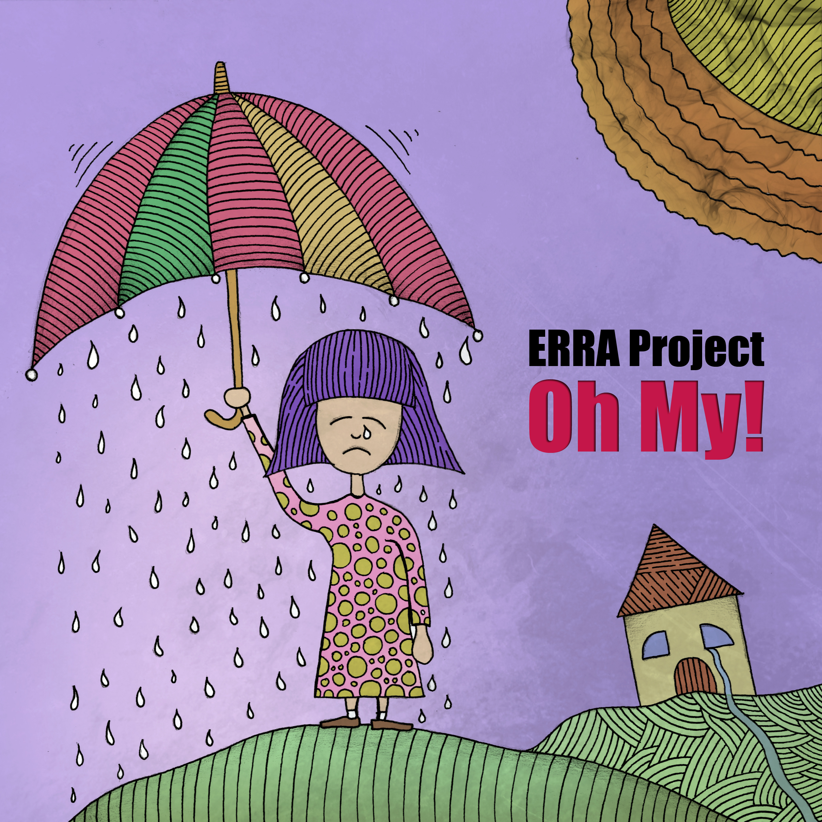
Irish multi-genre electronic music producers ERRA Project release new tech house E.P. – “Oh My!”
The ERRA Project was formed in early 2016 by Cork, Ireland based sound technician and musician Ciaran O’Brien, and Tipperary, Ireland based music producer and DJ Steffen Coonan, with the vision to enrich people’s lives through collaborative music projects. The ERRA Project formed upon the member’s realisation that they shared the same musical taste and production goals.

Tech House EP “Oh My!” was inspired by sounds from east Europe, Berlin and Amsterdam based clubs. The EP is homage to the great nights these institutions provide and the loving connections one makes with fellow revelers, even if the love is transient. The music contained within is designed to integrate easily into house and techno DJ sets. Music created by DJ’s, for DJs.

Ciaran O’Brien has worked freelance as an audio technician and guitar player for almost 10 years. Steffen Coonan is the founder of the successful media solutions service “Hillyfield Productions” and popular Deep House website www.DJSteffenCoonan.com. Find the ERRA Project’s music and contact them at:

https://erraproject.bandcamp.com/album/oh-my-3
https://www.youtube.com/watch?v=PHWG6Pljx-o
www.erraproject.com
https://twitter.com/ErraProject
https://www.facebook.com/erraproject
####

